How to Make a Beautiful Slinky Bracelet
Follow the easy steps below to make your very own gorgeous slinky bracelet in just 30 minutes.
Materials:
* Memory wire * 2 charms/trinkets
* Coloured beads * Long nosed pliers
* 20 spacer beads * Round nosed pliers
* 11 silver tubes
Method:
- Cut the memory wire to the required length using the long nosed pliers.
- Make a loop at one end of the memory wire using the round nosed pliers and hang a charm.
- Thread a spacer bead, followed by a feature bead and then another spacer bead onto the memory wire.
- Thread a silver tube onto the slinky wire.
- Continue threading spacer beads, feature beads and silver tubes until the bracelet is complete.
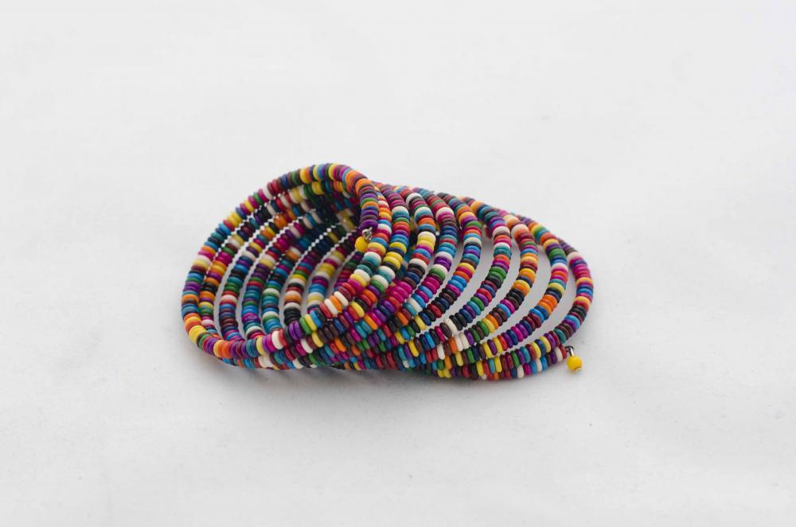
- Make a loop at the end of the memory wire and hang the second charm.

